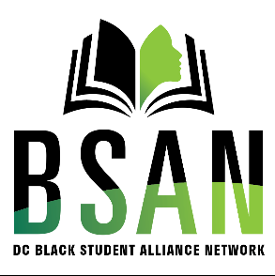
DC Black Students Alliance Network
Membership Registration Form

Name: ………………………………………………………………………………………………………………

Email:……………………………………………………………………………………………………………….

Contact Number:……………………………………………………………………………………………

Student Number:……………………………………………………………………………………………..

Area of Study:…………………………………………………………………………………………………..

Year Of Study:………………………………………………………………………………………………….
I agree to abide by the rules and regulations of The Black Student Success Network Club that may be in force from time to time. I also agree that my membership may be terminated immediately if the club’s disciplinary committee concludes that I did not abide by the club’s rules, regulations, general instructions and failed to maintain the club’s decorum.
I also agree that submission of this application does not certify approval. Approval will need to be given through the perusal of the executive body of the Black Student Success Club.

Signature:……………………………………………………………………………………………………….

Date:……………………………………………………………………………………………………………….

